**Chapter 1**

**INTRODUCTION**

* 1. **Introduction**

Augmented reality (AR) is an interactive experience of a real-world environment where the objects that reside in the real world are enhanced by computer-generated perceptual information, sometimes across multiple sensory modalities, including [visual](https://en.wikipedia.org/wiki/Visual), [auditory](https://en.wikipedia.org/wiki/Hearing), [haptic](https://en.wikipedia.org/wiki/Haptic_perception), [somatosensory](https://en.wikipedia.org/wiki/Somatosensory_system) and [olfactory](https://en.wikipedia.org/wiki/Olfactory). An augogram is a computer generated image that is used to create AR. Augography is the science and practice of making augograms for AR. AR can be defined as a system that fulfills three basic features: a combination of real and virtual worlds, real-time interaction, and accurate 3D registration of virtual and real objects. The overlaid sensory information can be constructive (i.e. additive to the natural environment), or destructive (i.e. masking of the natural environment). This experience is seamlessly interwoven with the physical world such that it is perceived as an [immersive](https://en.wikipedia.org/wiki/Immersion_(virtual_reality)) aspect of the real environment. In this way, augmented reality alters one's ongoing perception of a real-world environment, whereas [virtual reality](https://en.wikipedia.org/wiki/Virtual_reality) completely replaces the user's real-world environment with a simulated one. Augmented reality is related to two largely synonymous terms: [mixed reality](https://en.wikipedia.org/wiki/Mixed_reality) and [computer-mediated reality](https://en.wikipedia.org/wiki/Computer-mediated_reality).

Augmented Reality is a combination of a real and a computer-generated or virtual world. It is achieved by augmenting computer-generated images on real world. It is of four types namely marker based, marker less, projection based and superimposition based augmented reality. It has many applications in the real world. AR is used in various fields such as medical, education, manufacturing, robotics and entertainment. Augmented reality comes under the field of mixed reality. It can be considered as an inverse reflection of Virtual Reality. They both have certain similarities and differences. This paper gives information about Augmented Reality and how it started. It analyses various types of augmented reality, its applications and its advantages and disadvantages. This paper also gives us knowledge regarding those

major threats that augmented reality will face in the near future and about its current and future applications. It gives us a comparison between the two related topics, Augmented reality and Virtual reality. The following paper also helps us know about the effect of Augmented Reality on human life.

**1.2 Motivation**

Augmented Reality has its origin from the word ‘Augment’ meaning to add or enhance. The term Augmented Reality was given by Boeing Researcher, Tom Caudell. Augmented Reality (AR) is overlapping or augmenting digital images on real world objects using various AR apps. AR intensifies one’s understanding of the real world. AR can be defined as the system in which real and virtual worlds have been combined, there is real time interaction, and the device is registered in 3D. Here, the augmentation is being done in real time. One can say that AR is a technology in between the real reality and the virtual reality.

AR includes graphics, sounds and touch feedback which are then added to the real world. This creates an enriched user experience. All in all, AR helps improve user experience, helps in spreading knowledge, education and health. AR includes the concepts of Computer Vision and Computer Graphics. It needs vision to get a clear understanding of the real world and needs graphics to create false elements to augment it. Firstly, the real world is captured. The real world is the target. Then, the virtual world is modelled. Finally, the digital information or the virtual world is augmented or projected on the target. This is how AR is achieved.

Augmented Reality allows us to interact with the real and virtual worlds at the same time. It is an example of Intelligence Amplification (IA), as told by Fred Brooks, which means using computer as a tool so as to make it easier for a human to perform a task. Thus, this technology has been applied in many fields some of which are Medical, Entertainment and Games, Manufacturing, Robotics and Education. Augmented Reality will be far-reaching in the near future. It is being widely used in the healthcare sector where there is a need of visualizing the medical information and the patient within the same physical space. Augmented Reality can be used to perform surgeries and can help surgeons perform real time surgeries without being physically present near the patient. Augmented Reality can be proved to be a game-changer for entertainment and games. Here, it is possible to interact with the real world and reel world using this technology. Augmented reality has also helped in improving the understanding of the product assembly tasks to be carried out. Information overload and the training required for assembly operation can be reduced using the AR approach.

In the field of robotics, AR makes it easier for robots for communicating complex information to humans. Moreover, this technology can help robots perform surgeries by combining AR with surgical robot system for performing head surgeries. In a nutshell, AR is a platform that has made human-robot collaboration possible.

Augmented reality in education has been proved to be very fruitful. The young learners can now visualize complex spatial relationships [7] and abstract concepts. This technology helps students to engage in phenomena that are not possible in real world. Moreover, the invisible concepts [7] like magnetic field can now be visualized easily using AR.

**1.3 Problem statement**

Augmented Reality is a platform that helps us blend real and virtual worlds while giving equal space to both. It is like a double-edged sword. It is useful and positive at one place but has many disadvantages too. Augmented Reality can be used to increase the knowledge bars of people but its availability is improper in social situations. AR can help people share experiences over long distances but there are no strong security features in this technology. AR has a form of escapism but AR has a feature of spam. A life-like experience can be established by AR games but There are various issues like that of performance, alignment and interaction.

Augmented Reality allows us to interact with the real and virtual worlds at the same time. It is an example of Intelligence Amplification (IA), as told by Fred Brooks, which means using computer as a tool so as to make it easier for a human to perform a task. Thus, this technology has been applied in many fields some of which are Medical, Entertainment and Games, Manufacturing, Robotics and Education. Along with the success comes necessary threats and challenges. Augmented Reality also has some of the threats that may risk its success in the near future. Some of the top threats to AR’s success in the near future have been studied in the paper.

**Chapter 2**

**LITERATURE SURVEY**

**2.1 Introduction**

In [1] **Mekni, Mehdi, and Andre Lemieux, "Augmented reality: Applications, challenges and future trends." ,Applied Computational Science— Proceedings of the 13 th International Conference on Applied Computer and Applied Computational Science (ACACOS ‘14) Kuala Lumpur, Malaysia. 2014: pp. 205, 207 - 209**

Augmented reality, in which virtual content is seamlessly integrated with displays of real-world scenes, is a growing area of interactive design. With the rise of personal mobile devices capable of producing interesting augmented reality environments, the vast potential of AR has begun to be explored. This paper surveys the current state-of-the-art in augmented reality. It describes work performed in different application domains and explains the exiting issues encountered when building augmented reality applications considering the ergonomic and technical limitations of mobile devices. Future directions and areas requiring further research are introduced and discussed.

The term Augmented Reality (AR) is used to describe a combination of technologies that enable real-time mixing of computer-generated content with live video display. AR is based on techniques developed in VR and interacts not only with a virtual world but has a degree of interdependence with the real world. As stated in hugues11, “augmenting” reality is meaningless in itself. However, this term makes sense as soon as we refocus on the human being and on his perception of the world. Reality can not be increased but its perceptions can be. We will however keep the term of Augmented Reality even if we understand it as an ”increased perception of reality”. Ronald Azuma and his team provided valuable and rich surveys on the field of augmented reality in 1997 and later in 2001. However, the last decade has been particularly rich in advances in this growing research field which opened perspectives for several opportunities to use AR in various application domains. To the best of our knowledge, no updated surveys in the literature have holistically addressed AR technologies with respect to the numerous application domains, the impact of mobile technology and the relationship that holds between AR and Virtual Reality (VR). For anyone who wants to get acquainted with the field of AR, this survey provides an overview of recent technologies, potential applications, limitations and future trends of AR systems. Introduces technologies that enable an augmented reality experience, clarifies the boundaries that exist between AR and Virtual Reality (VR), and focus on the contributions of mobile technology in AR. Classifies the identified applications of AR into 12 distinct categories including well established domains like medical, military, manufacturing, entertainment, visualization, and robotics. It also describes original domains such as education, marketing, geospatial, navigation and path planning, tourism, urban planning and civil engineering. Identify and discuss the common technological challenges and limitations regarding technology and human factors. Finally, concludes with a number of directions that we believe AR research might take.

In [2], **Tang, S. L., Kwoh, C. K., Teo, M. Y., Sing, N. W., & Ling, K. V., (1998). “Augmented reality systems for medical applications”, IEEE engineering in medicine and biology magazine, 17(3): pp. 51**

Augmented reality (AR) is a technology in a which a computer-generated image is superimposed onto the user’s vision of the real world, giving the user additional information generated from the computer model. This technology is different from virtual reality, in which the user is immersed in a virtual world generated by the computer. Rather, the AR system brings the computer into the “world'' of the user by augmenting the real environment with virtual objects. Using an AR system, the user’s view of the real world is enhanced. This enhancement may be in the form of labels, 3D rendered models, or shaded modifications. In this article we review some of the research involving AR systems, basic system configurations, ima,:e-registration approaches, and technical problems involved with AR technology. We also touch upon the requirements for an interventive AR system, which can help guide surgeons in executing a surgical plan.

In industry, AR can be ;applied in various areas such as repair and maintenance of complex engines, facilities modification, previewing proposed buildings in their natural settings, and interior design. For example, in the repair and maintenance of complex engines, the AR system can provide labels that aid mechanics in identifying engine components. Additional data such as maintenance reports, schematic!;, manufacturer’s specifications, and repair procedures may be retrieved and displayed next to the specified component observed in the real environment.

In a prototype system by Neumann, AR is used to aid airplane-factory workers in assembly operations. The system can highlight locations for drilling or display instructions on where and how to apply a particular sealant. The AR prototype system uses pattern-recognition software to determine the particular unit under construction and to establish the correct spatial relationship between the camera and the object.

In medical applications, a computer generated virtual organ (or major blood vessel distribution) will be superimposed onto the surgeon’s view of the patient, giving spatial information of the organ relative to the patient’s body, or simply “X-ray” vision. During a surgical procedure, computed tomography (CT), magnetic resonance imaging (MRI), ultrasonography, or other imaging methods are used to obtain information to aid in surgical planning. These medical images are mostly two-dimensional and are obtained preoperatively. One of the shortcomings of using preoperatively obtained images is that these images can only be used as references for surgical planning prior to the actual operation. Another shortcoming is that they do not provide spatial information of the organ relative to the patient’s body, even though 3D reconstruction is possible using images of the organ in different planes. In this article, our focus will be on ultrasonography, because it is the only imaging method that can be used intraoperatively and is free from radiation hazard. The benefit of having intraoperative medical images is that they provide real time interaction with the surgery. This helps to provide spatial information of the organ relative to the patient’s body. However, most ultrasonic images are only two-dimensional, and the surgeon is required to scan across the targeted area in order to “see” the organ in different planes. Upon “seeing” the organ, the surgeon can only try to visualize the 3D volume of the organ in his mind, and subsequently complete his surgical plan before proceeding with the operation. This is not always possible due to the complexities of the geometry involved (such as visualization of tumors within the organ). Moreover, visualization of 3D volume in this manner does not give the surgeon accurate spatial information of the volume relative to the patient’s body, thus compromising effectiveness of the treatment.

In [3] **“Augmented reality systems for medical applications”,**[**Son-Lik Tang**](https://ieeexplore.ieee.org/author/38182030200) **;** [**Chee-Keong Kwoh**](https://ieeexplore.ieee.org/author/37443587300) **;** [**Ming-Yeong Teo**](https://ieeexplore.ieee.org/author/37339731200) **;** [**Ng Wan Sing**](https://ieeexplore.ieee.org/author/37726160900) **;** [**Keck-Voon Ling**](https://ieeexplore.ieee.org/author/37341033000)

Augmented reality (AR) is a technology in which a computer-generated image is superimposed onto the user's vision of the real world, giving the user additional information generated from the computer model. This technology is different from virtual reality, in which the user is immersed in a virtual world generated by the computer. Rather, the AR system brings the computer into the "world" of the user by augmenting the real environment with virtual objects. Using an AR system, the user's view of the real world is enhanced. This enhancement may be in the form of labels, 3D rendered models, or shaded modifications. In this article, the authors review some of the research involving AR systems, basic system configurations, image-registration approaches, and technical problems involved with AR technology. They also touch upon the requirements for an interventive AR system, which can help guide surgeons in executing a surgical plan.

Augmented reality— in the form of Google Glass, Sony’s SmartEyeglass, or Microsoft HoloLens— may appear to solve that problem. These devices present contextual information transparently or in a way that obscures little, seemingly letting you navigate the world safely, in the same way head-up displays enable fighter pilots to maintain situational awareness. • But can augmented reality really deliver on that promise? We ask this question because, as researchers at Kaiser Permanente concerned with diseases that impair mobility (Sabelman) and with using technology to improve patient care (Lam), we see dangers looming. • With augmented-reality gear barely on the market, rigorous studies of its effects on vision and mobility have yet to be done. But in reviewing the existing research on the way people perceive and interact with the world around them, we found a number of reasons to be concerned. Augmented reality can cause you to misjudge the speed of oncoming cars, underestimate your reaction time, and unintentionally ignore the hazards of navigating in the real world. And the worst thing about it: Until something bad happens, you won’t know you’re at greater risk of harm.

There’s a simple way to fix this, of course. The GPS receivers built into wearables already detect the speed of motion (at least outdoors); designers could use them to stop notifications when the user is moving. And many AR wearables have cameras, so image analysis could likewise trigger a safety mode indoors in situations likely to cause trouble. So technically, there are straightforward solutions. But they aren’t likely to be used: The last thing the people buying wearables want is to stop the flow of information—ever. The whole point of the devices is to stay connected no matter what you are doing. So there are—and will continue to be— hazards engendered by AR wearables— at least when the user is on the move. We turned to studies conducted with visually impaired people and others using early versions of wearable AR to find out exactly what those hazards are. We also found that some of these studies suggest that augmented reality has the potential to help some people with disabilities to overcome their impairments.

**Chapter 3**

**System Architecture**

**3.1 Proposed Model:**

This section provides how Augmented Reality allows us to interact with the real and

virtual worlds at the same time how a computer can be used as a tool so as to make it easier for a human to perform a task. This technology has been applied in many fields such as the following:

Medical

Augmented Reality will be far-reaching in the near future. It is being widely used in the healthcare sector (as shown in figure1) where there is a need of visualizing the medical information and the patient within the same physical space . Augmented Reality can be used to perform surgeries and can help surgeons perform real time surgeries without being physically present near the patient. Some of the real life examples where AR is being used in medical field are:

* EyeDecide : This is a medical app which simulates the impact of specific conditions or medicines on a person’s vision using a camera.
* AccuVein : This app uses a handheld camera which projects over the skin. Thus nurses and doctors get to know where the veins are in the patients’ bodies. 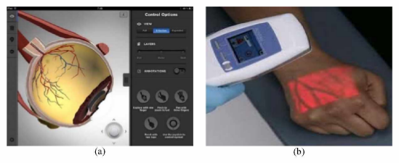

Fig 3.1 Applications of AR in Medical : (a) EyeDecide App, (b) AccuVein App

Entertainment and Games

Augmented Reality can be proved to be a game-changer for entertainment and games. Here, it is possible to interact with the real world and reel world using this technology. AR can be used in Television Broadcasting. Many sports channels use AR thus allowing the audience to view graphic overlays. AR is widely used in Gaming too. Apps such as Ingress and Pokémon Go use augmented reality to let gamers play with virtual characters in the real world.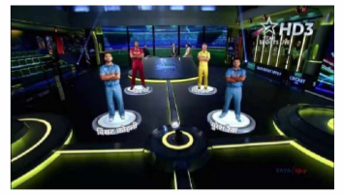

Fig 3.2 Applications of AR in Games and Entertainment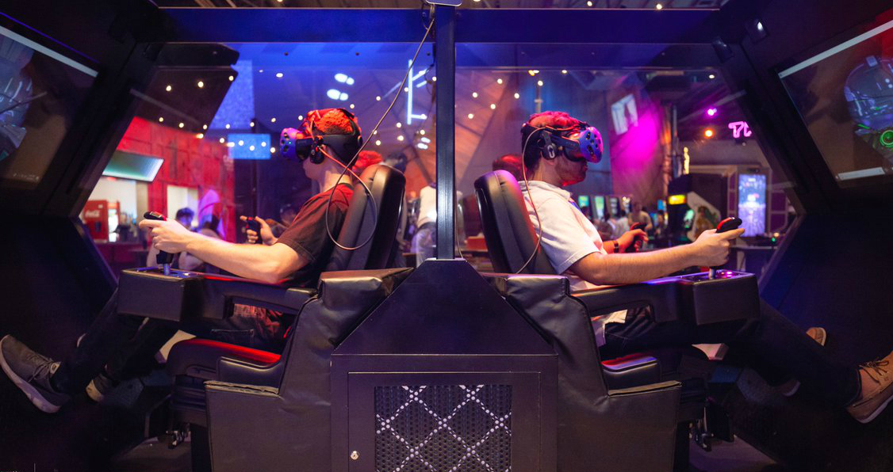

Manufacturing

Augmented reality has helped in improving the understanding of the product assembly tasks to be carried out. Information overload and the training required for assembly operation can be reduced using the AR approach. In manufacturing, AR can help in complex assembly of machinery, in maintenance of parts and in providing expert support.

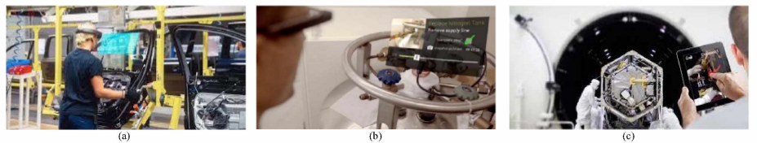

Fig 3.3 Using AR in Manufacturing: (a) In complex assembly, (b) In maintenance, and (c) in providing expert support

Robotics

In this field, AR makes it easier for robots for communicating complex information to humans. Moreover, this technology can help robots perform surgeries by combining AR with a surgical robot system for performing head surgeries. In a nutshell, AR is a platform that has made human-robot collaboration possible.

Education

Augmented reality in education has been proved to be very fruitful. The young learners can now visualize complex spatial relationships and abstract concepts. This technology helps students to engage in phenomena that are not possible in the real world. Moreover, the invisible concepts like magnetic fields can now be visualized easily using AR. Augmented Reality can open additional ways and methods of learning process easier and interesting. Classrooms and books become interactive. There are some AR student apps also. Some of them have been mentioned below.

* AugThat: This app helps boost education process with 360o virtual photos and 3D lessons.
* Elements 4D: This app is for exploring chemistry. It allows students to see how different elements react in reality.
* Zookazam: It is an app which allows us to do oral explanations in 3D models. It has a large content including insects, birds, animals, fishes and reptiles.

AUGMENTED REALITY AND VIRTUAL REALITY

As we know that Augmented Reality is a fusion between the real world and the digital world. On the other hand, there is Virtual Reality. It is an artificial, computer generated recreation of a real world situation. One can say that AR and VR are inverse reflections of one another in terms of what they want to achieve and deliver to the user. And because both of the technologies are interconnected with one another there are some of the similarities and differences between them which have been described below.

Similarities:

(a) Technology. Similar type of technology is being used by both AR and VR. They both occur to serve the society with an intensified experience.

(b) Entertainment. With AR and VR, the user has a control on the artificial or virtual worlds. The user can interact deeply with the reality.

(c) Science and Medicine: Both AR and VR have the capacity to change the aspects of medical field i.e. by making remote surgeries possible. These technologies have already been used to treat diseases such as PTSD (Post Traumatic Stress Disorder).

Differences:

(a) Purpose: Both the technologies have different purposes. AR magnifies user experience by adding virtual components such as graphic overlays as a new layer of interaction with the real world. Whereas VR shapes its whole new reality which is purely computer-based.

(b) Delivery Method: AR is generally used in mobile devices such as laptops, smartphones, and tablets. It is used in such a way so as to change the way real world

and digital images interact and intersect. While VR uses HMDs i.e. head-mounted displays or hand-held controllers.

**Chapter 4**

**Experiments**

**4.1 Result Analysis**

Along with the success comes necessary threats and challenges. Augmented Reality also has some of the threats that may risk its success in the near future.

TOP THREATS TO AUGMENTED REALITY

1. Lack o f Use Cases

AR is fun for gaming [12] but it has no actual purpose. None could find a reason to pay so much money for a device which has no useful purpose.

2. Legal

There are various privacy concerns related to AR. People are being filmed unknowingly. This technology hasn’t even reached that headset form properly and there are already things like Pokémon Go Death Tracker. This tracker tells us about the number of deaths that happened while playing the famous AR game Pokémon Go. The AR companies are not able to navigate the legal issues presented when operating at scale.

3. Digital Fatigue

In this digital world, we are already hooked up to our screens all the time. And if we use AR headsets then we’ll be constantly having virtual information. This can be very exhausting. This leads to a conclusion that technology may prove to be a destruction to the society.

4. Miniaturization Issues

AR headsets have a reasonably large size which could be just worn on the head but not like normal eyeglasses. Everyone wants their headsets to be AR functional but at the same time wants it to be of the size of eyeglasses.

5. Poor Experience

The technology of augmented reality has been a dull experience because of technical deficiencies like poor resolution and inaccurate computer vision.

6. Social Rejection

Because the normal public fears change, no one wants to accept AR as a part of his life. They find AR as weird and socially awkward. They don’t want to wear a computer sized headset on their faces every time. This leads to social rejection of the technology. This has been the major threat to AR’s success because it is not easy to convince people.

OVERCOME THE THREATS

One can conquer such problems because AR has the ability to increase the manufacturing productivity by 30%. Moreover, when the masses are introduced to some new technics, they fail to predict its power. In the coming years, AR will have a stronger potential. Nowadays, we spend most of our time in our virtual worlds inside our laptops and smartphones. But this time is not beneficial. Whereas through AR, the time we would be spending in our virtual worlds may become efficient and will make us more connected to the real world. Augmented reality gives us a chance to be a part of digital world while experiencing the real world. The AR which is being developed today is not the AR of today but the AR of 10 years from now which will be reforming the world.

MICROSOFT HOLOLENS

It is a technology that has brought AR and VR together. HoloLens doesn’t take us to a completely different simulated world. Through HoloLens, we can stay in our same environment but can have access to various digital elements augmented on the top of the physical object around us. Through HoloLens, we can even interact with the digital images layered in the real reality.

Fig 4.1 Microsoft Hololens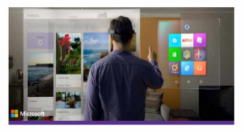

NEGATIVE IMPACTS OF AUGMENTED REALITY

We have known many applications of Augmented Reality in many fields such as medical, manufacturing, education and robotics. But like a coin has two sides, Augmented Reality can harm our lives to the same extent at which it can ease our lives. It can destroy us both physically and mentally. One cannot ignore the number of lives that Pokémon Go (an AR game) has taken. By using AR it means that we are constantly looking at our screens. This may lead to several eye diseases, mental illnesses and may destroy our posture. AR can even threaten our privacy . While traveling it may increase distractions when using AR navigation techniques. Augmented reality can lead us to misinterpret the speed of oncoming cars, underestimate our reaction time, and unintentionally ignore the dangers of navigating in the real world. “Until something bad happens, you won’t know you’re at greater risk of harm”.

**Conclusion**

In the paper it was studied about Augmented Reality and its various application in the field of medical, manufacturing, entertainment & games, robotics and education. We acquired knowledge about some apps such as EyeDecide, AugThat, Zookazam, etc. that use this technology of AR. We also concluded how the use of Augmented Reality can be beneficial in our day to day lives. This term paper gives information regarding different types of AR such Marker Based AR, Marker less AR, Projection Based AR and Superimposition Based AR. The technology of AR still under research and development and is emerging day by day. Many things have been developed recently using this technology. It has entered the world of car repair again after 5 years. In a nutshell, it can be said that AR has a very bright and promising future in spite of having many threats to its success in the near future. AR is not limited to wearable devices. AR makes passive objects interactive. It is the future of product design. There is an app named Layar which connects digital information with the real world. It scans the printed material enriched with Layar through which we can view digital experiences related to that material. This could help the industries because instead of producing various unconnected products, industries will now have to produce only one single product. Digital layers of information would be printed on that one product which could then be viewed through the Layar app. Users can get richer reading experience and a product team could work in a united manner. Recently, Augmented Reality has entered the world of car repair yet again. Porsche dealerships are using the technic of AR to diagnose and repair cars. This helps in saving the technician’s time and helps avoid tiresome on-site visits of the expert. By using AR, the car service time has been reduced by 40%. In a nutshell, it can be said that AR has a very bright and promising future in spite of having many threats to its success in the near future.